CAP LASER LAB – LENS RESPONSIBILITY FORM
The College of Architecture and Planning provides access to the Universal Laser Machines for students to use for coursework while enrolled in CAP programs at Ball State University. All users are responsible for receiving the required training and certification prior to using the machines. These machines are regularly serviced and also inspected by the lab’s manager and attendants to ensure they work properly.
Critical to using the lasers is the process of focusing the lens based upon the thickness of the material being cut; this MUST be done for each type of (approved) flat-stock being cut PRIOR to using the machine otherwise the lens can be burned. The proper height of the bed is determined using the focusing jig, positioned between the top of flat-stock and the bottom of the flat black lens holder, assuring the correct distance between the material and the lens. Every laser user is responsible for assuring the laser lens is the correct distance from the approved flat-stock material. If the lens is burned during use, the person using the laser will be charged the lens replacement cost.
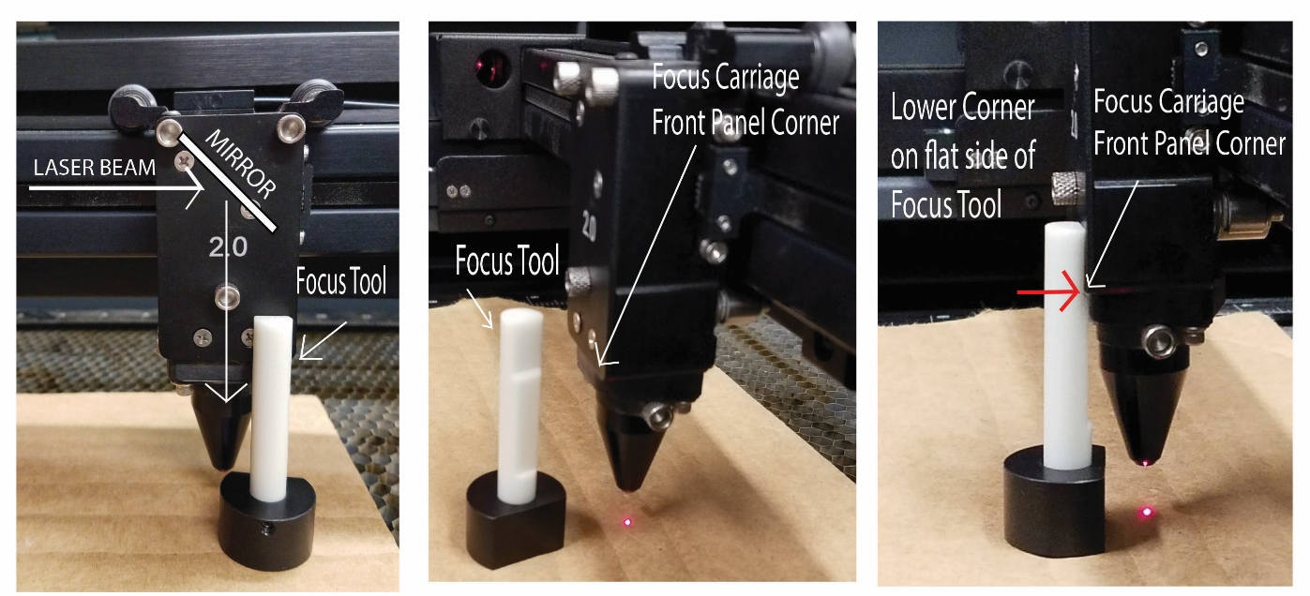
I am aware that if I burn a lens in a CAP laser machine that I am responsible to pay the replacement cost for the lens (roughly $250).

I _______________________________________________ am using machine ____________________
(Print First Last Name)
and agreeing to the conditions above. I realize that I will be billed (as described above) if my use of the laser results in a burned lens.
____________________________________________ ________________________
(Signature) (Date AND Time)
____________________________________________ ___________________
Printed FAB Lab Attendant Name (Date AND Time)

